

NAME:
MAHEEN RAZA

ROLL NO:
FA22-BSE-086

CLASS:
BSE-8B

SUBJECT:
DEVOPS FOR CLOUD COMPUTING

SUBMITTED TO:
SIR MUHMMAD IBRAHIM

SUBMISSION DATE:
3/30/ 2026

Step 1: Installing Terraform
First, Terraform was installed on the Ubuntu system using command-line tools. The Terraform binary was downloaded, extracted, and moved to the system path.

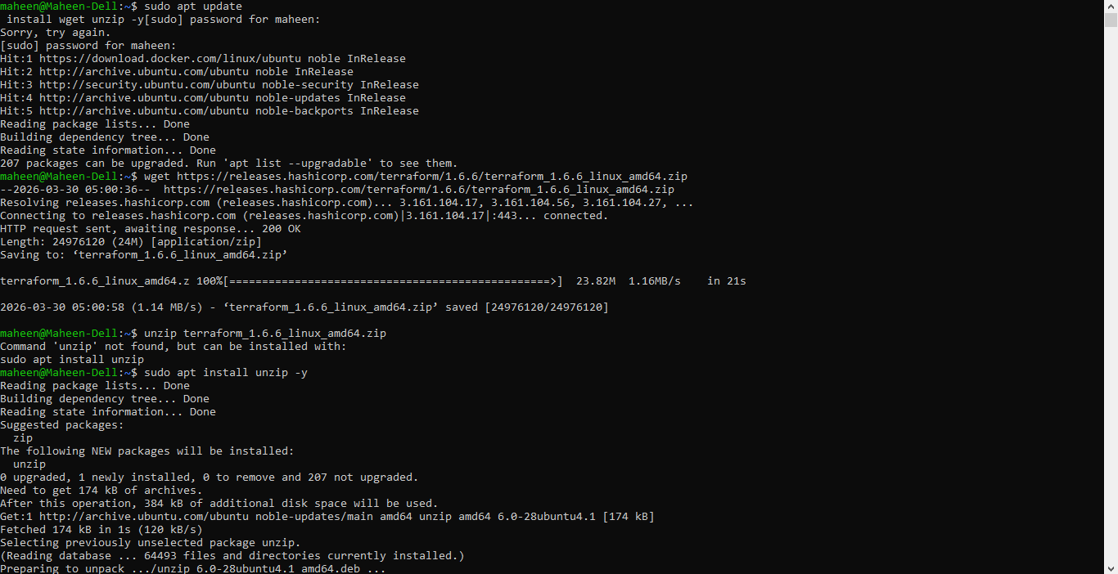

Step 2: Configuring AWS CLI
AWS CLI was installed and configured using access keys obtained from the AWS Management Console. This step allows Terraform to authenticate with AWS.

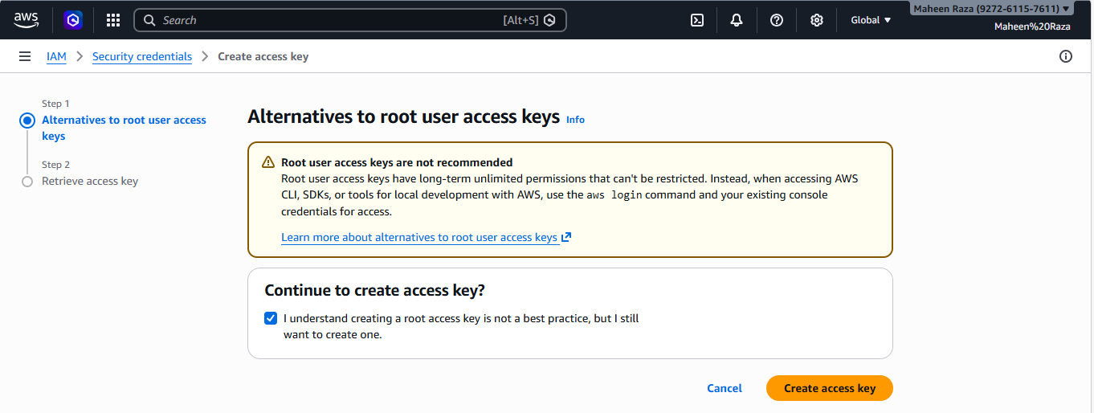
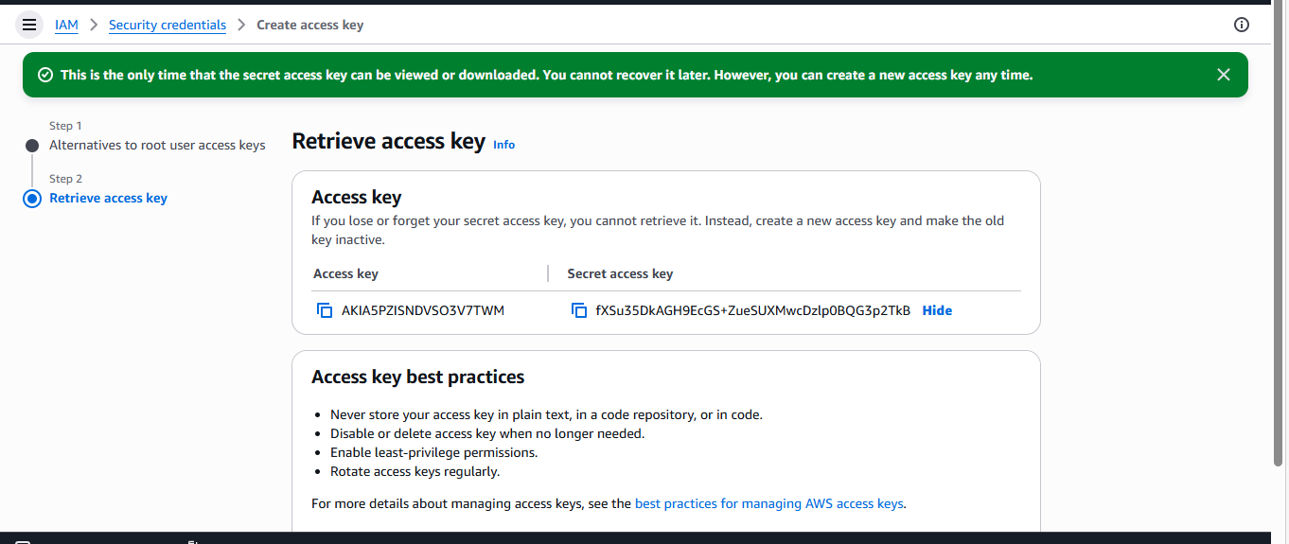
Step 3: Creating Project Directory
A new directory named terraform-project was created to store Terraform configuration files. This helps organize the project properly.

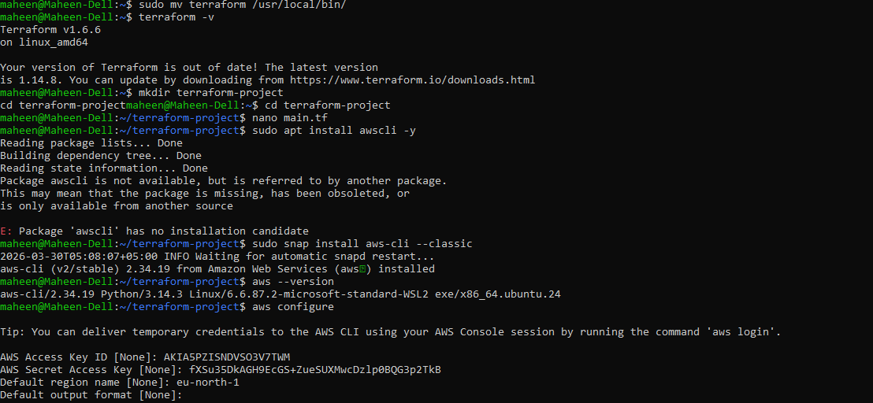

Step 4: Initializing Terraform
The command terraform init was executed to initialize the working directory and download necessary provider plugins.

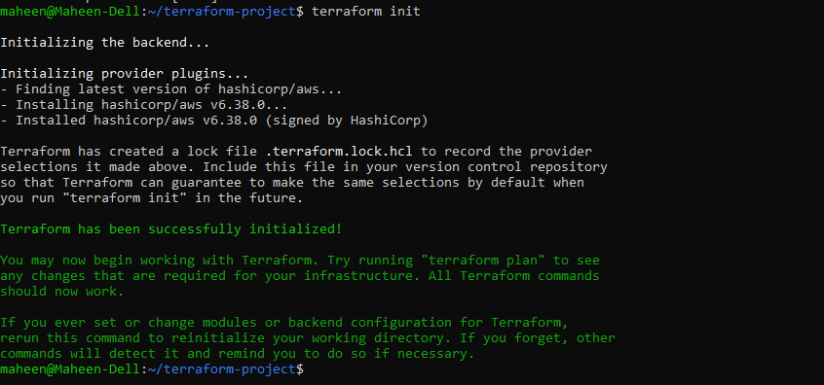
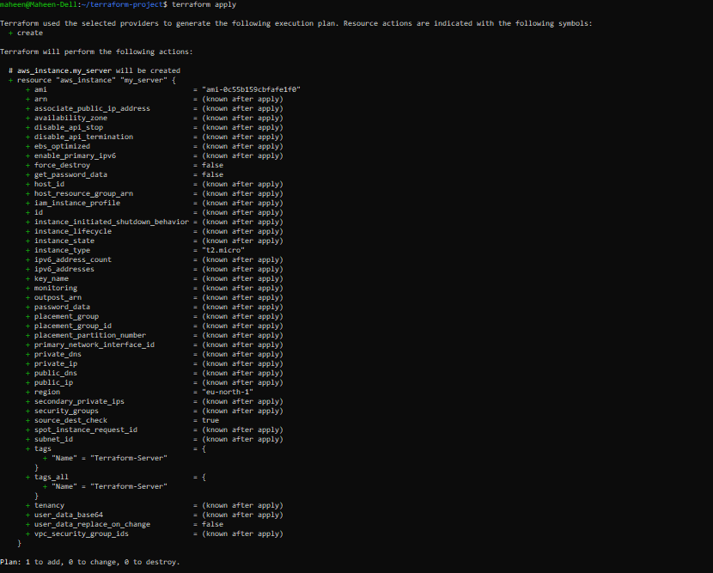
APPLY:
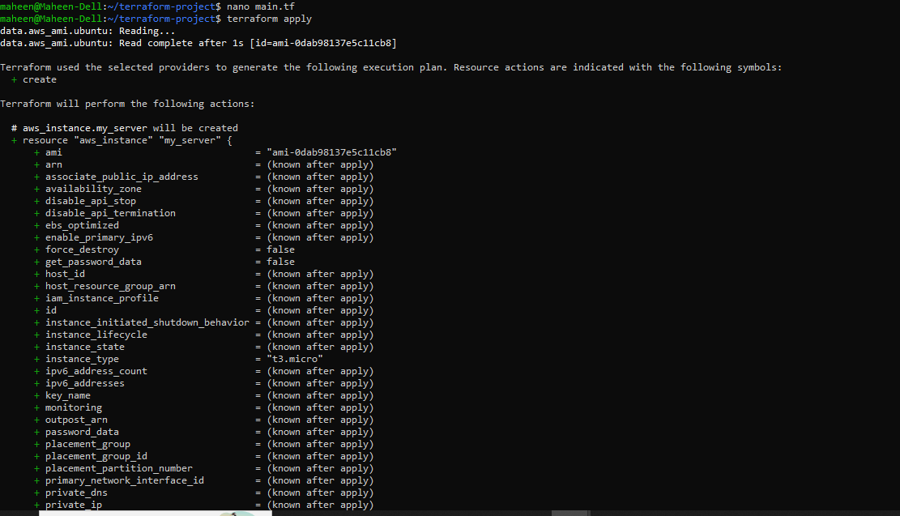
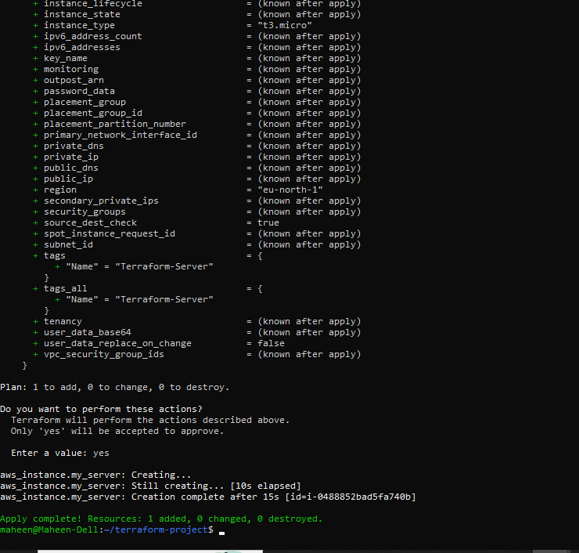
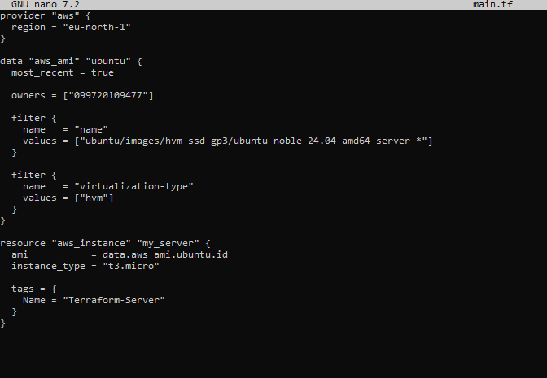
DESTROY:
